ALPE - ADRIA - CANOE – SLALOM
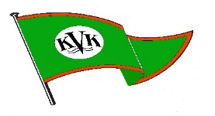

Austria – Klagenfurt – Kärnten
River Gurk
Sunday, October 3rd 2021

Gurker Brücke WW 2
Rules: ICF
Categories :K1w/ K1m/ C1w/ C1m/ C2 /
Seniors/ Juniors/ Youth (U 14)

Entries until September 29th 2021
to Kajak –Verein Klagenfurt
Theodor-Prosen-Gasse 49/ A 9020 Klagenfurt
susi.winkler50@gmail.com / +43 676-9225033 / office@kajakverein-klagenfurt.at
Please only use the attached excel-list!
We will confirm your entries!
€ 15,--/each start// € 50,--Deposit (Bips) each Club
Late entries will not be accepted.
Training until 17.00 on 2.10./ Teamleader - meeting 9.00/3.10.
Start 1. run 10.00/ / Awards ceremony Sen., Jun. ca 12.00
Start Youth : 12.15 /Awards Ceremony 15.00

Covid-regulations as valid at the the time of the event have to be followed
Anti-doping regulations of Canoeing Austria are valid for the competition

You will find the route to our Slalom-Course on
www.kajakverein-klagenfurt.at

